Point tests for conductivity measurements
T.N.Olstoorn 051126

Introduction
For a more detailed analysis conductivity values may be necessary on smaller within the aquifer. However, it is difficult to get good conductivity data in practice. Sampling and laboratory methods of unconsolidated samples lead to testing of disturbed samples, for which it is unclear how the conductivity relates to the value in the field.
Pumping tests or slug tests measure conductivity on a larger scale, unsuitable to study a small scale such as the flow around galleries, below infiltration ponds and so on.
Slug tests suffer from the difficulty that only a value of k/S is obtained (Kruseman & De Ridder, 1994).
An alternative method is a point test using a very small screen in the aquifer and performing a small-scale pumping or injection test or a falling or rising head test. The problem with point tests is, generally, that the hydraulic resistance (skin) and shape at the bottom of the hole are not unclear defined (Uffink, 1979).
A method employed during CPT (cone penetration testing) seems too unreliable, which is perhaps due to smearing effect during the penetration of the cone (oral information GeoDelft, own experience).
In this paper, point tests are proposed using well-defined conditions in the soil. The conditions are obtained by bringing in an open pipe by hammering and simultaneous flushing out of sand and material, which enters the pipe during its descend. Care is taken not to flush ahead of the pipe. The flushing guarantees a flat and clean pipe bottom, which allows for a successful falling or rising head test. Because the sand is continuously removed from the bottom of the pipe, no extreme soil pressures occur at the end of the pipe during it’s descend, most resistance is from friction along the outer pipe wall.
The point tests are to be carried out in the dunes near Haarlem, to measure conductivity. The measurements will be done by a falling or rising head test in an open pipe with a flat and clean bottom. The soil consists of fine dune sands having a conductivity of around 10 m/d. At some depths silty sands will be encountered with lower conductivities.
The pipe will be hammered in while the sand moving into the pipe during hammering is continuously flushed out. The bottom will thus be clean and no influence by clogging is to be expected during the test.
The sequel of this paper is the preparatory analysis of the tests. This is done with a radially symmetric groundwater flow model, which is is used to accurately simulate the tests and to find out the sensitivities of the relevant parameters on the results

Modeling to prepare field tests
Modeling was done in Matlab using the function Radmodt, which is radially symmetric node-centered finite difference model (Olsthoorn, 1999), the columns and cells of which can be made arbitrarily fine, as is the case with the time steps.
To model the falling head test for the expected situation in the dune area, the model is made 8 m high, while the test is simulated 2 m below the water table. Vertical grid spacing is 10 cm, but refined down to 1 cm around the bottom of the pipe.
The radial grid extends from 1 mm to 100 m, with logarithmically increasing column widths (10 steps per log cycle).
The inner radius of the pipe is 2 cm. The outside of the pipe is represented by a column having vertical and horizontal conductivity equal to zero above the bottom of the pipe.
The free water inside the pipe is simulated by setting the horizontal and vertical conductivity of the model inside the pipe to 10⁶ m/d.
The specific storage coefficient S_{s} is set the same everywhere, equal to 10⁻⁵/m. To simulate the falling head test, the storage coefficient of the uppermost cells inside the pipe is set to 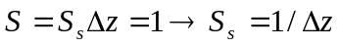, so that the total storage coefficient in the pipe becomes 1. Cells in the pipe below the uppermost ones keep their sand storativities, which are so small compared to that of the uppermost cells, that this does not influence the result.
The falling head is then simulated by setting the initial value of the head equal to zero everywhere in the model, except in the pipe, where it is set to 1.
The overall water balance of the model is checked, by comparing the water released from the pipe with that stored in the rest of the model after equilibrium is reached and both the pipe and ground have obtained the same head. To allow this balance computation, the model is completely closed at all it’s outer boundaries, so that there is no net outflow.

Results and analysis of the modeling
Figure 1 shows the head contours around the open end of the pipe for the 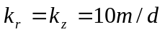 and 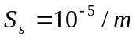. It is the result 24 seconds after the start of the falling head test with a water level in the pipe initially 1 m above the groundwater head. It is immediately clear that measurable head changes are limited to about 20 cm around the pipe bottom.
Because the measurable head changes are limited to only a couple of decimeters outside the pipe, no measurable influence is to be expected from boundaries further away than about 0.5 m. This holds true for the water table as well as a drain, disturbances due to insertion of the pipe and so on. It means that only during the last half meter above the point of measurement one must be very careful when hammering down the pipe.
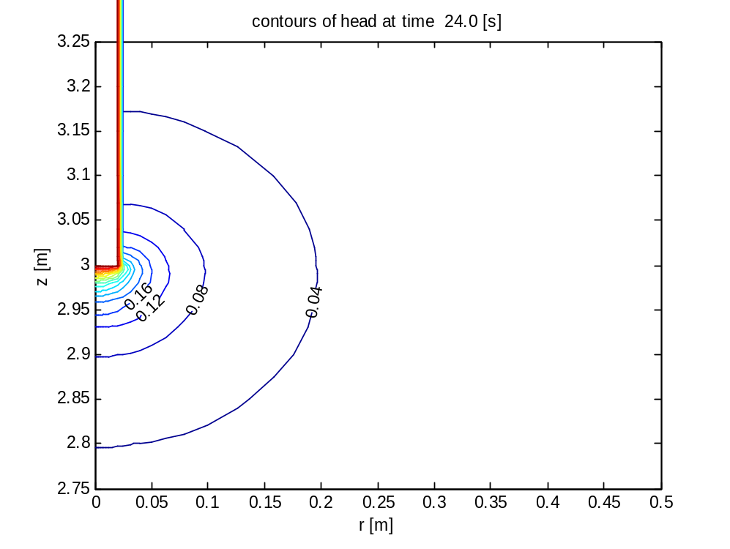
Figure 1: Computed contours around the end of the pipe for t=24 seconds during falling head test from 1 m difference initially (k=10 m/d, Ss=10⁻⁵/m)
Figure 2 demonstrates that the head is almost immediately in a quasi equilibrium for points near the pipe. The model needs to become stable in the beginning, which takes less than a second of the simulation period and does not disturb the rest of the analysis in the times relevant for the field tests. For larger distances, the head will gradually rise and fall. However, the maximum head changes are then so small that they are factually unobservable. The results also show that the test will take about 3 minutes to complete (full decay of the head). This will also be time of rest necessary before another test can safely be done. Another test could be a rising head test. This allows the determine the water level at rest, which is where the falling and rising head both approach to.
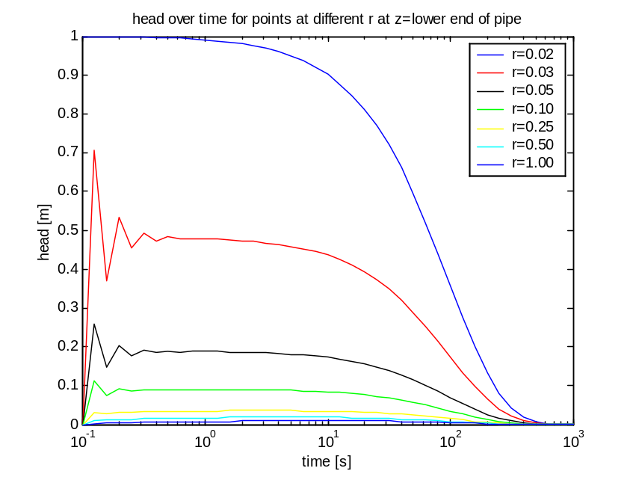
Figure 2: Head during falling head test for points at different distance from the pipe at elevation of pipe bottom
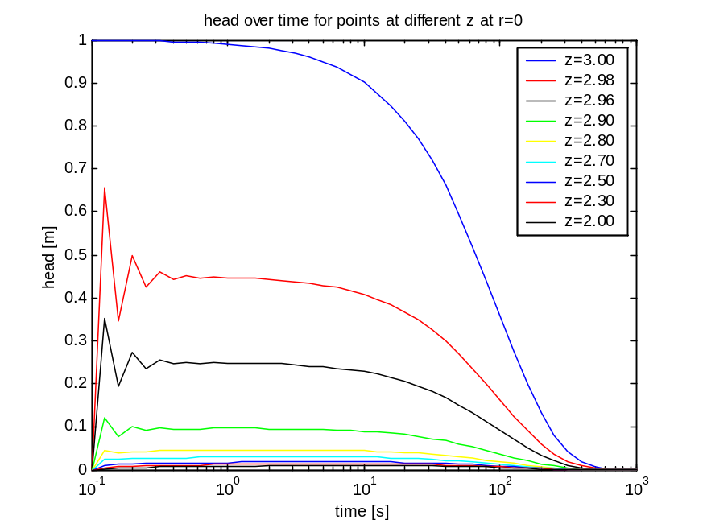
Figure 3: Head during falling head test for points at r=0.001 m and different values of z (z=3 m is elevation of bottom of the pipe).
Figure 3 is similar to Figure 2, but the points plotted are now below the pipe. The conclusions are the same.
The effect of conductivity can be seen by comparing the head at the bottom of the pipe for different values of the conductivity (Figure 4). The curves indicate a high sensitivity for the conductivity. This promises accurate results from the field tests, if other field conditions can be met, i.e. made to be similar enough to the model.
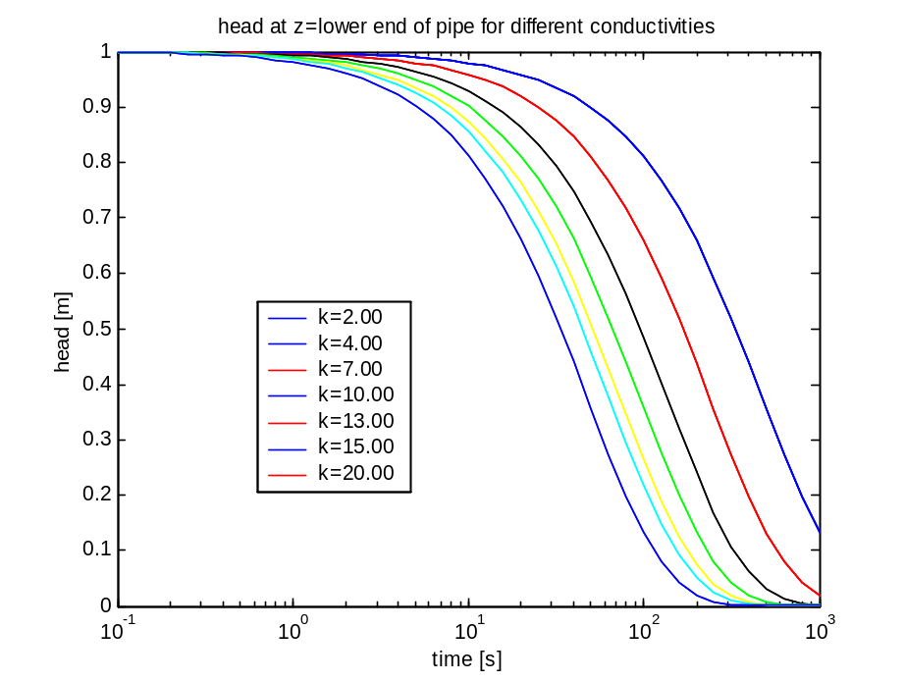
Figure 4: Head at bottom of pipe at different conductivity values
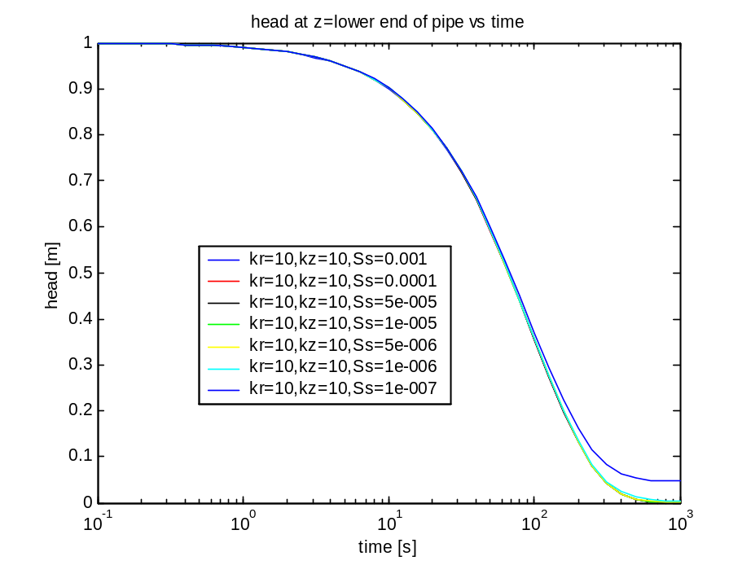
Figure 5: Effect of different specific storage coefficients. The higher tail for Ss=1e-7 is due to the closed boundaries of the model, the effect of the test reaches the boundary for this low storage coefficient.
Another question is the sensitivity of the falling head for the specific storage coefficient. This is computed in Figure 5. The figure shows that the results are independent of the storage coefficient. The lifted tail for 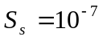 is due to the model being closed at all sides. For this low storativity, the effect of the falling head test reaches the outer boundary of the model (r=100 m) during the time of the test. This is therefore an artifact of the model, built in on purpose to prevent unnoticed boundary influences.
The absence of sensitivity of the storage coefficient is a consequence of the small scale and the slow decline of the water level in the pipe. As can be seen in Figure 2 the system seems to be almost steady state for early times. It is more or less always in a steady state situation. To see this, compute the characteristic time of this system at the scale of this system [order 1 m]
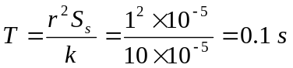
So for times much longer that T the system should be essentially steady state. This is already true after 1 second. During a constant rate infiltration test too, the flow is essentially steady state shortly after the start of the test (Uffink, 1979, p39).
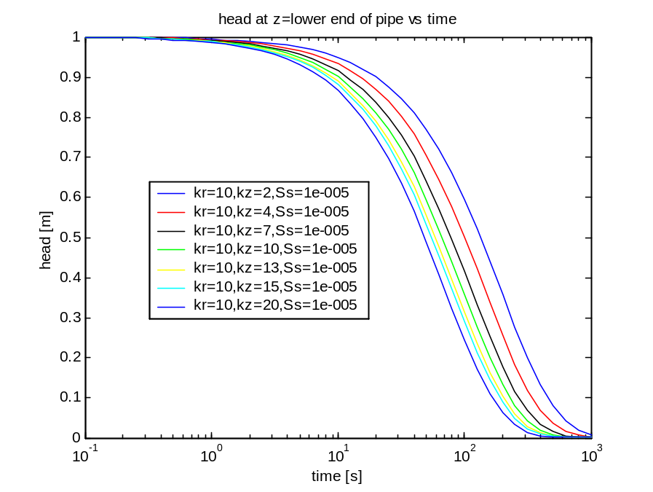
Figure 6: Effect of anisotropy seems to be small compared to conductivity as such.
The effect of anisotropy is shown in Figure 6. This effect is relatively small, mainly because the horizontal conductivity was held the same during the computations, while the horizontal conductivity is dominant in this radially symmetric flow system; this is so because the overall conductivity equals 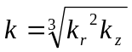. This effect is shown in the next computation, in which the overall conductivity was held the same at 10 m/d.
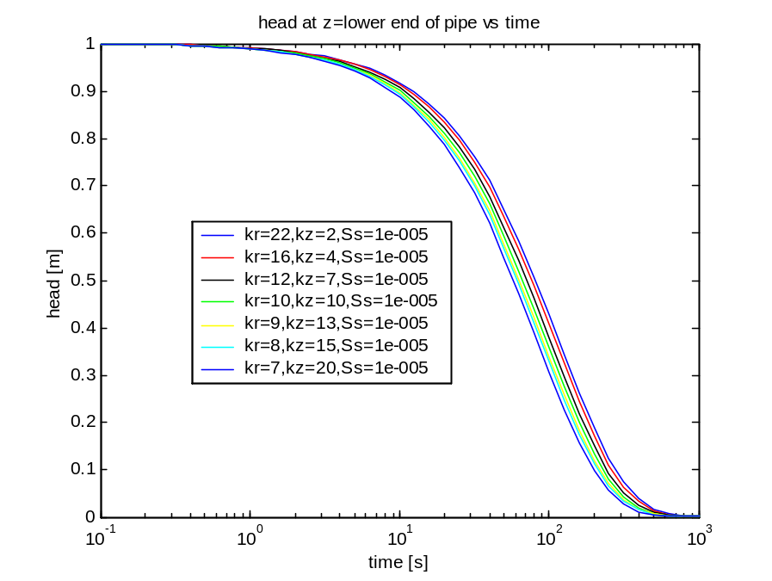
Figure 7: Results for anisotropic case where , i.e. the overall conductivity is always the same
As expected, the curves almost coincide; the only difference is due to the shape of the pipe and its bottom; the water must leave the pipe vertically, so that there is at least some influence of anisotropy. However, this influence seems to be too small to observe in practice.

Comparing with the analytic solution
The head change due to an instantaneous point sink equals (Lee, 2002, Uffink, 1979)
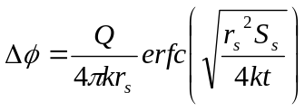
with the radius of a sphere contrary to that of the pipe used before.
Because the argument of erfc is greater than zero, and 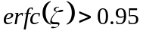 when 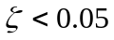 it follows that the head is virtually steady state for
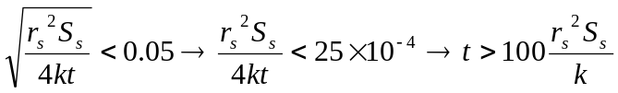
For the current case with 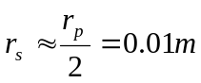 with 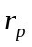 the radius of the pipe (see further down), 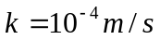 and this comes down to
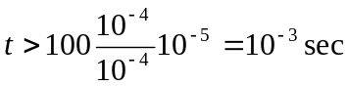
Hence the steady state is reached within half a minute in the case of a steady-state injection or abstraction test.
Choosing 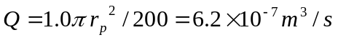 which is similar to the falling head test which took about 200 seconds to let the head fall from 1 m to zero
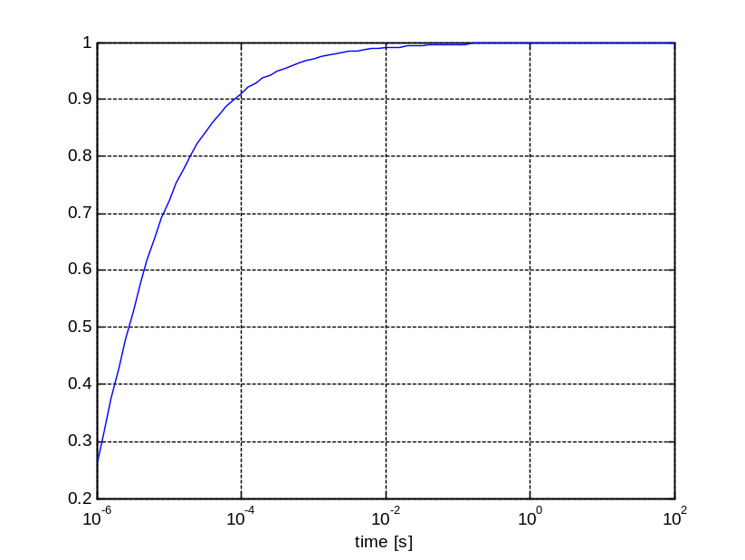
Figure 8: Analytic solution 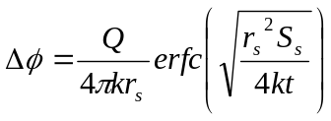 for , , 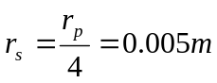, 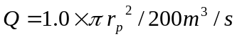. The head seems to become exactly one; this is however coincident of the choice of Q. At least it shows that the analytic solution leads to essentially the same result as the model. 95% of the steady-state value is reached in about 0.001 s as computed before.
Hence, for this test almost no waiting is necessary. Also, because of the immediate steady state flow situation the flow can be obtained from the initial lowering rate or generally from
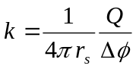
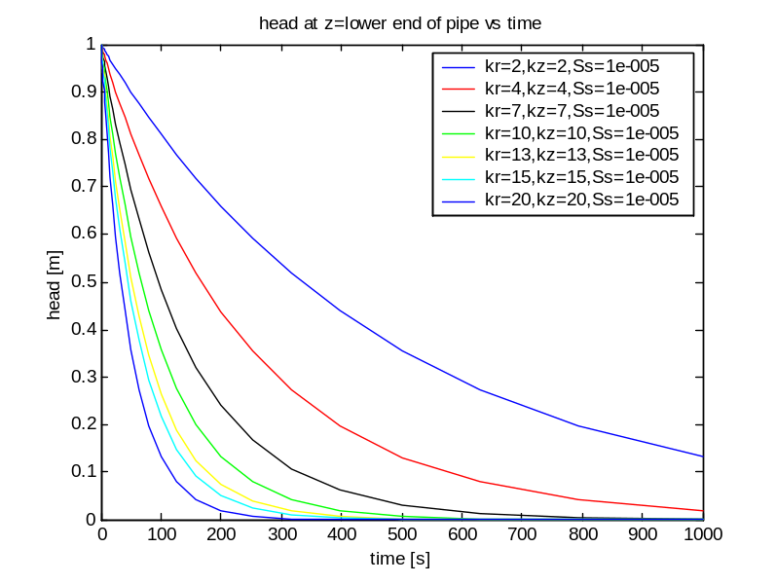
Figure 9: The model results as Figure 2 but at linear scale
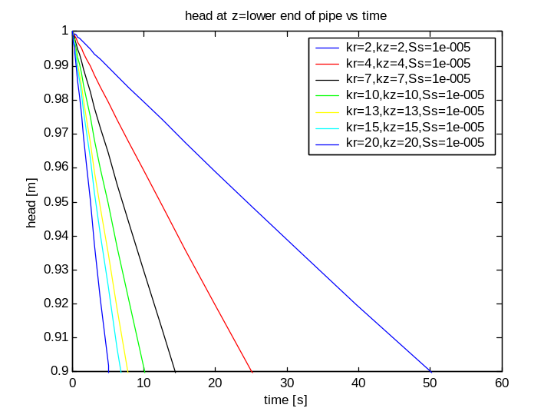
Figure 10: Same as Figure 9 but zoomed in at upper part to see initial linear fall of head with time
The slowest curve yields 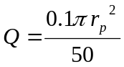m³/s. With this yields
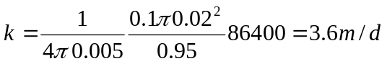
The value is similar but substantially greater than that used in the model (namely 2 m/d). The difference is due to the that between the shape of the open pipe and the ideal spherical situation.
We may match the model with the analytic solution by choosing an appropriate ratio between r_{s} and r_{p}. Taking 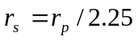 returns the values used in the model. Filling in:
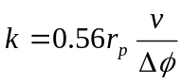
where is the falling rate of the water table in the pipe around when the head equals 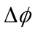 compared to the value at rest. For the curves above, 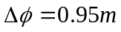 and a time in which the water table in the pipe falls over a distance of 0.1 m equals 50, 25, 14.2, 10.0, 7.9, 6,8 and 5.2 seconds as measured from the graphs.
Therefore,
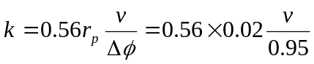
This gives after multiplying by 86400 to obtain values in m/d: 2.0 4.1, 7.2, 10.2, 12.8, 14.9 and 19.6 m/d respectively, which is close enough to the original values of 2, 4, 7, 10, 13, 15 and 20 m/d.

We may also write
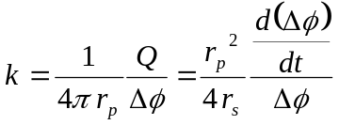
so that
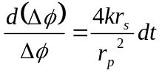 or 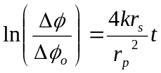
or
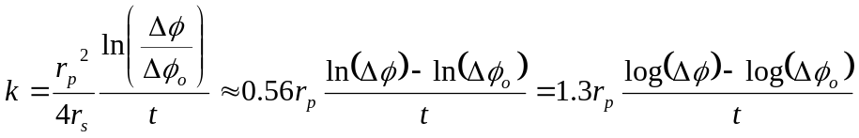
It is therefore, useful to plot the head on vertical log scale versus time on a linear scale and select an arbitrary point from the straight line portion of the curves, from which the conductivity may be directly computed using the expression above.
Figure 11 gives the curves on logarithmic scale for the heads, from which points have been selected arbitrarily to compute the conductivity. The selected points and the computed conductivities are in the table below.
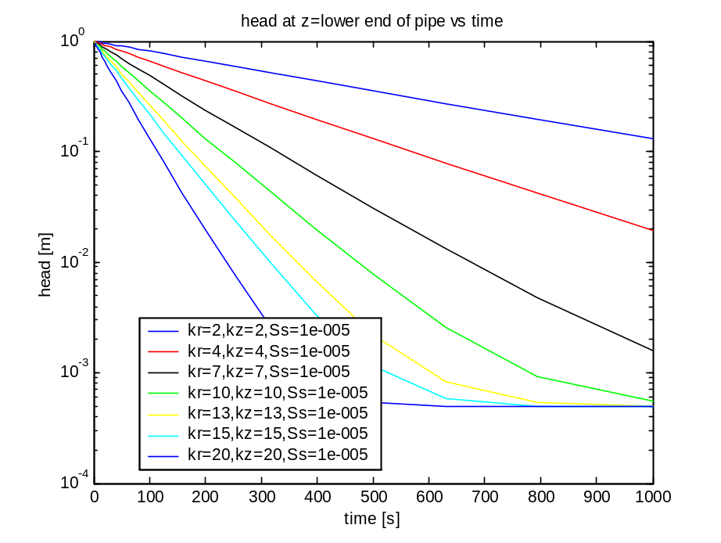
Figure 11: log of the head in the pipe versus time
Selecting a value for in on each of the lines in Figure 11 and computing the conductivity according as outlined, yields the table below (conductivities have been converted from m/s to m/d, not shown). These are close to the values that went into the model. The latter method is, therefore the most simple. In fact there is no difference here between a constant rate or a falling head test, because the situation is in all circumstances quasi steady state.
Table 1: Computed conductivities from Figure 11 by picking a point on the straight parts of each line and computing the conductivity. The values are close to the values used in the model.
Time t |  | 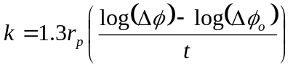
531 | 0.336 | 2.0
425 | 0.176 | 4.0
323 | 0.103 | 6.9
257 | 0.076 | 10.0
229 | 0.0538 | 12.4
204 | 0.0470 | 14.6
204 | 0.0188 | 19.0

Conclusion
In conclusion, the method seems suitable to measure the overall conductivity in situ. This conductivity will resemble the horizontal conductivity because of 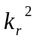 in the overall value .
There is no effect of the storage coefficient. Therefore, the method promises accurate values for the overall conductivity, especially if the falling head is measured accurately, which can be achieved with modern piezometer loggers.
From the comparison between the analytic and numeric solution it follows that in the case of a flat bottom of the pipe instead of an ideal spherical well screen, we should apply a spherical well screen radius of 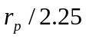 where is the radius of the pipe.
From the comparison with the analytic ideal solution it follows that the conductivity may be computed directly from the rate of fall of the head without any further complicated analysis or even simpler from the graph or log(t) versus t.
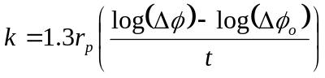

References
Lee, T-C. (1999) Applied Mathematics in Hydrogeology. Lewis Publishers. Boca Raton etc. 1-56670-375-1, 377pp.
Kruseman G. & N.A. De Ridder (1970) Analysis and evaluation of pumping test data. ILRI, International Institute on Land Reclamation and Improvement. Bulletin 11, Wageningen, The Netherlands.
Olsthoorn, TN (1999) Several Matlab groundwater flow models presented in the coures “modeling without ready made models”. PAO, Delft
Uffink, GJM (1979) De bepaling van k-waarden in het veld aan de hand van “putproeven” en “puntproeven”. Resultaten van het onderzoek aan de Parkweg (Den Haag). RID mededeling 79-2.

